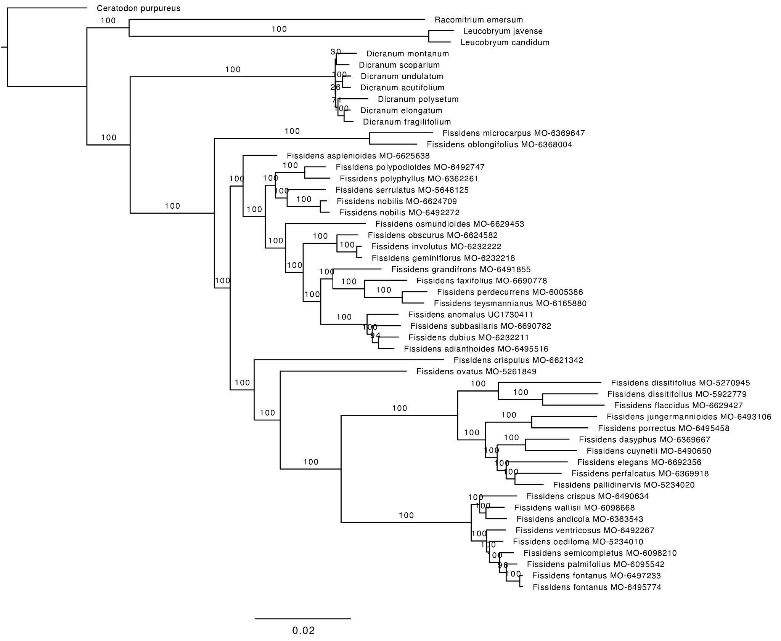
Fig. S1. Fissidentaceae Maximum Likelihood phylogram based on the analysis of 404 concatenated exon regions (probe dataset). This included a total aligned supermatrix of 74,441 nucleotides and 94 partitions, using RAxML with the GTRGAMMA substitution model. Branch lengths are proportional to substitutions per site and support from 1,000 rapid bootstrap replicates are indicated by the numbers on the branches.
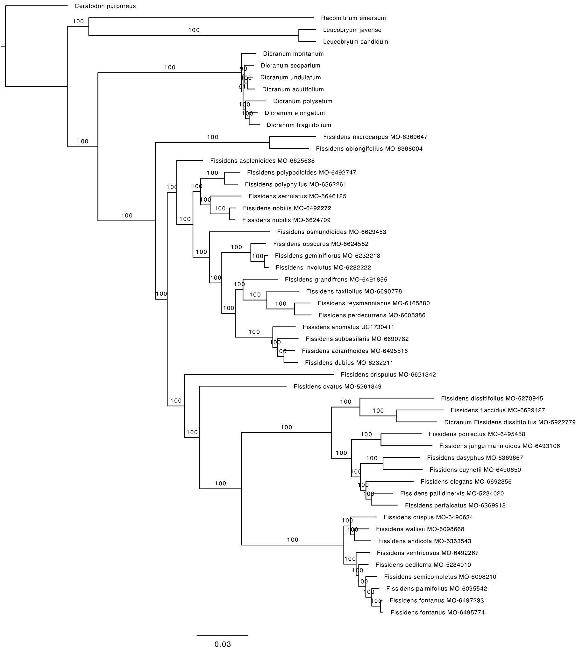
Fig. S2. Fissidentaceae Maximum Likelihood phylogram based on the analysis of 404 concatenated exon and the flanking regions (full dataset). This included a total aligned supermatrix of 493,051 nucleotides and 154 partitions, using RAxML with the GTRGAMMA substitution model. Branch lengths are proportional to substitutions per site and support from 1,000 rapid bootstrap replicates are indicated by the numbers on the branches.
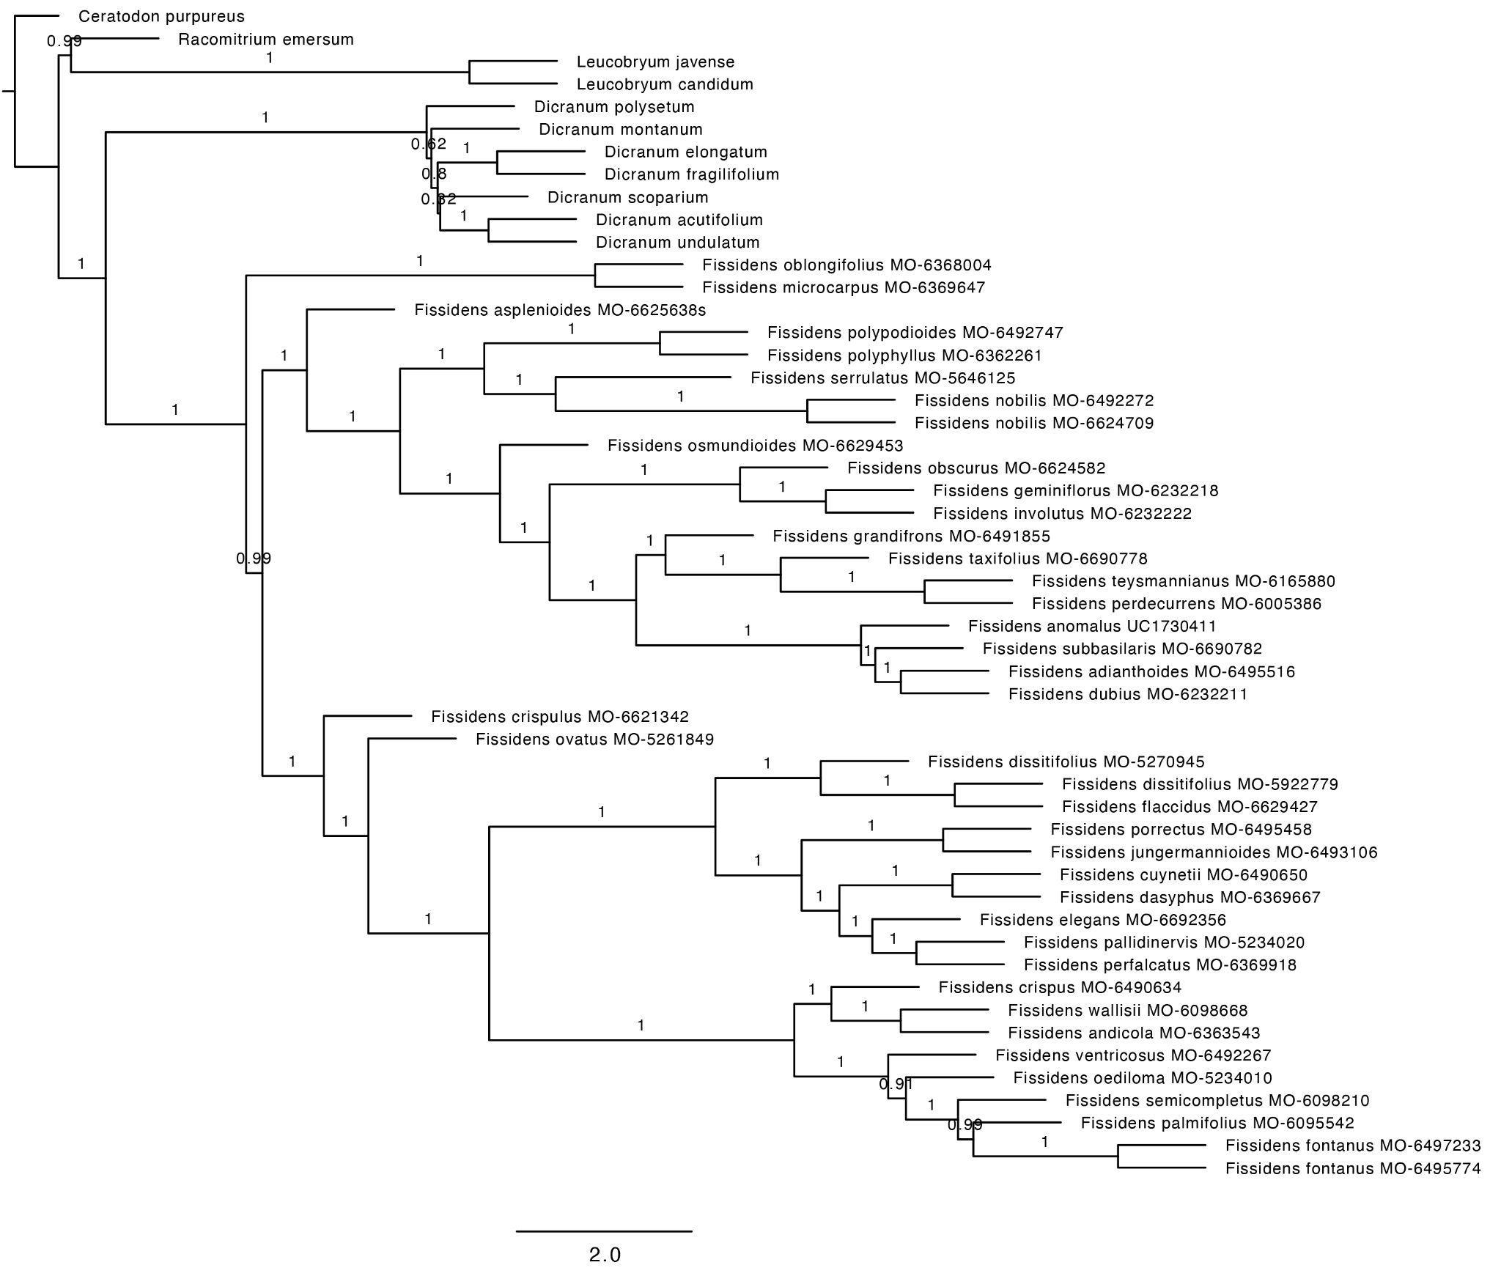
Fig. S3. Fissidentaceae species phylogeny. Inferred from 404 RAxML gene trees built from exon regions only (probe dataset) using the summary coalescent method ASTRAL-III with each locus treated as a single partition. Branch lengths are in coalescent units (2*N generations), with support values indicating local posterior probability (LPP).
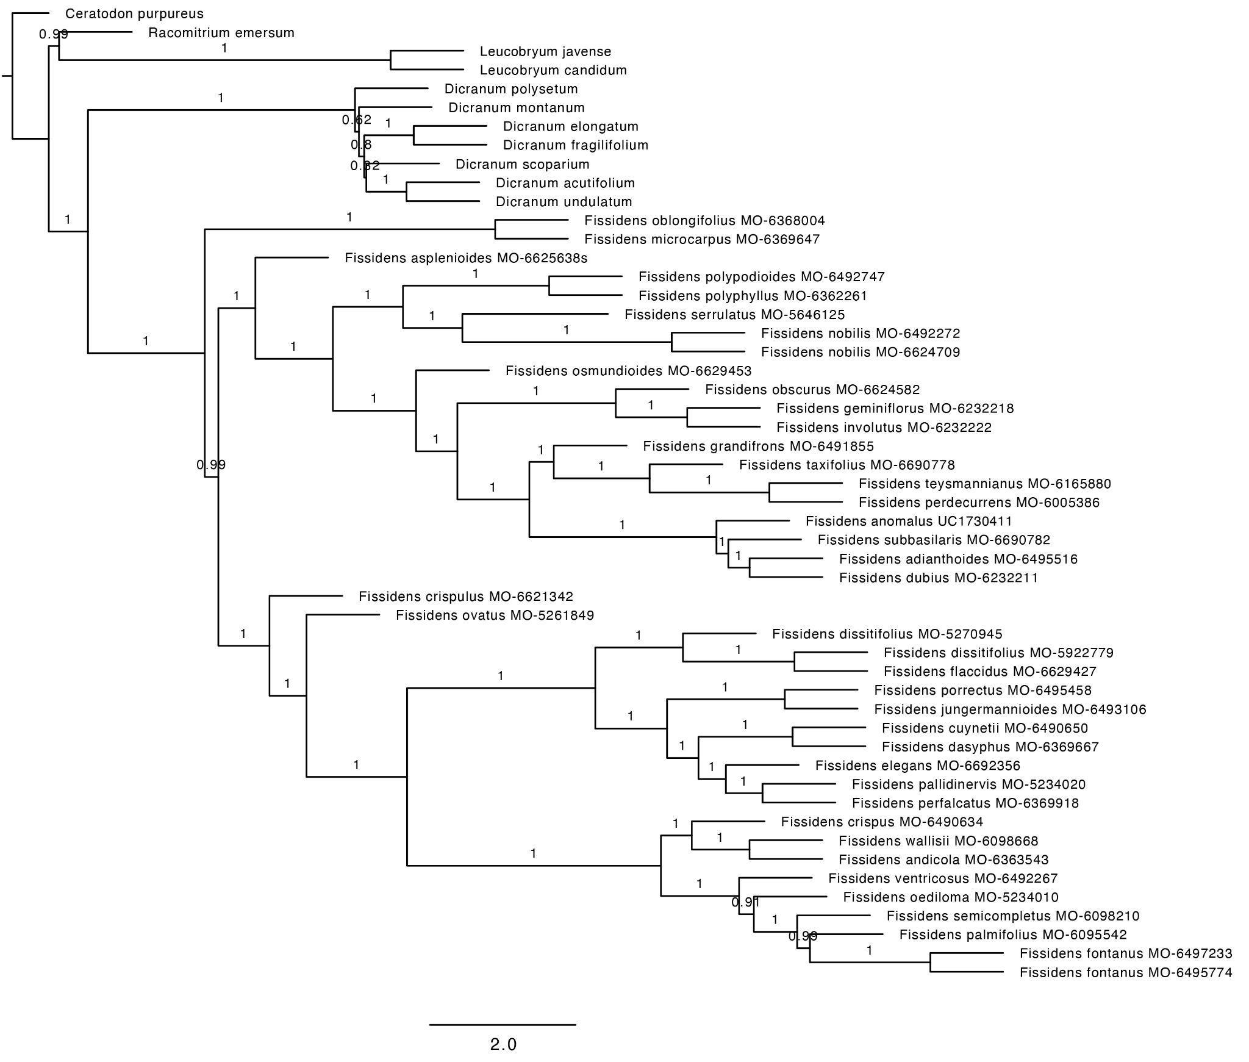
Fig. S4. Fissidentaceae species phylogeny. Inferred from 404 RAxML gene trees built from the exon and flanking regions (full dataset) using the summary coalescent method ASTRAL-III with each locus treated as a single partition. Branch lengths are in coalescent units (2*N generations), with support values indicating local posterior probability (LPP).
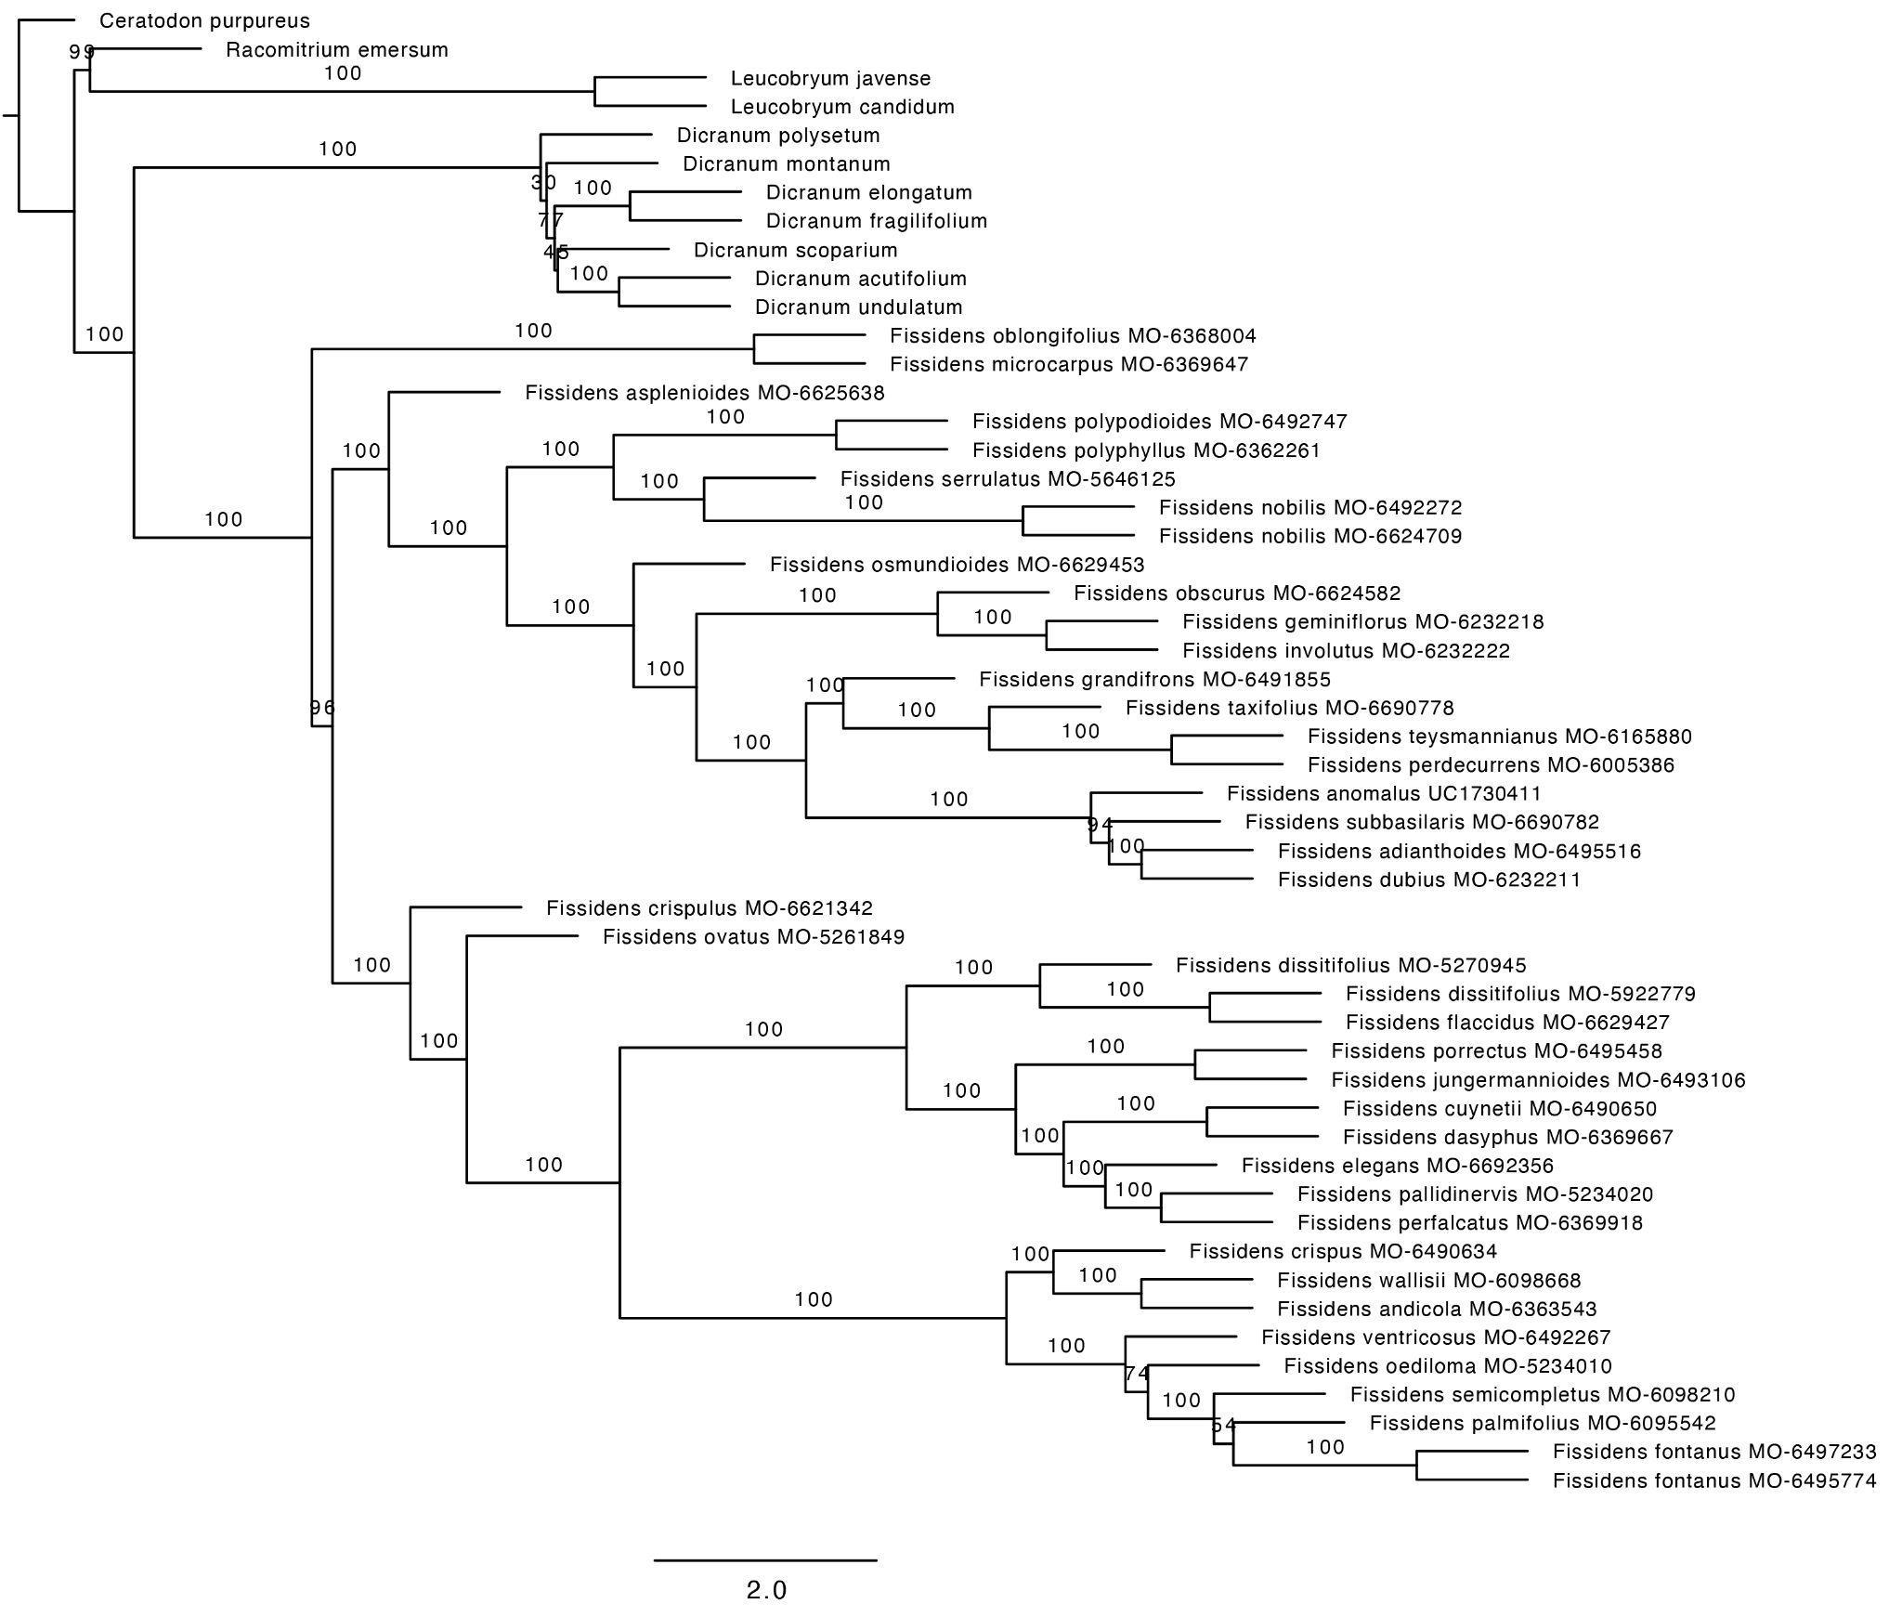
Fig. S5. Fissidentaceae species phylogeny. Inferred from 404 RAxML gene trees built from exon regions only (probe dataset) using the summary coalescent method ASTRAL-III with each locus treated as a single partition. Branch lengths are in coalescent units (2*N generations), with support values indicating multilocus bootstrap (MLBS) values from 100 replicates.
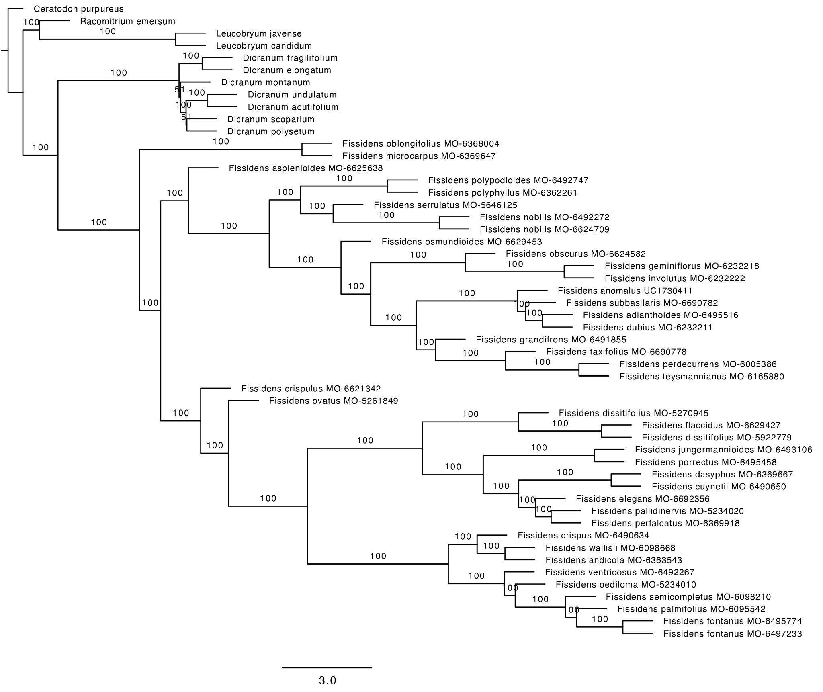
Fig. S6. Fissidentaceae species phylogeny. Inferred from 404 RAxML gene trees built from the exon and flanking regions (full dataset) using the summary coalescent method ASTRAL-III with each locus treated as a single partition. Branch lengths are in coalescent units (2*N generations), with support values indicating multilocus bootstrap (MLBS) values from 100 replicates.
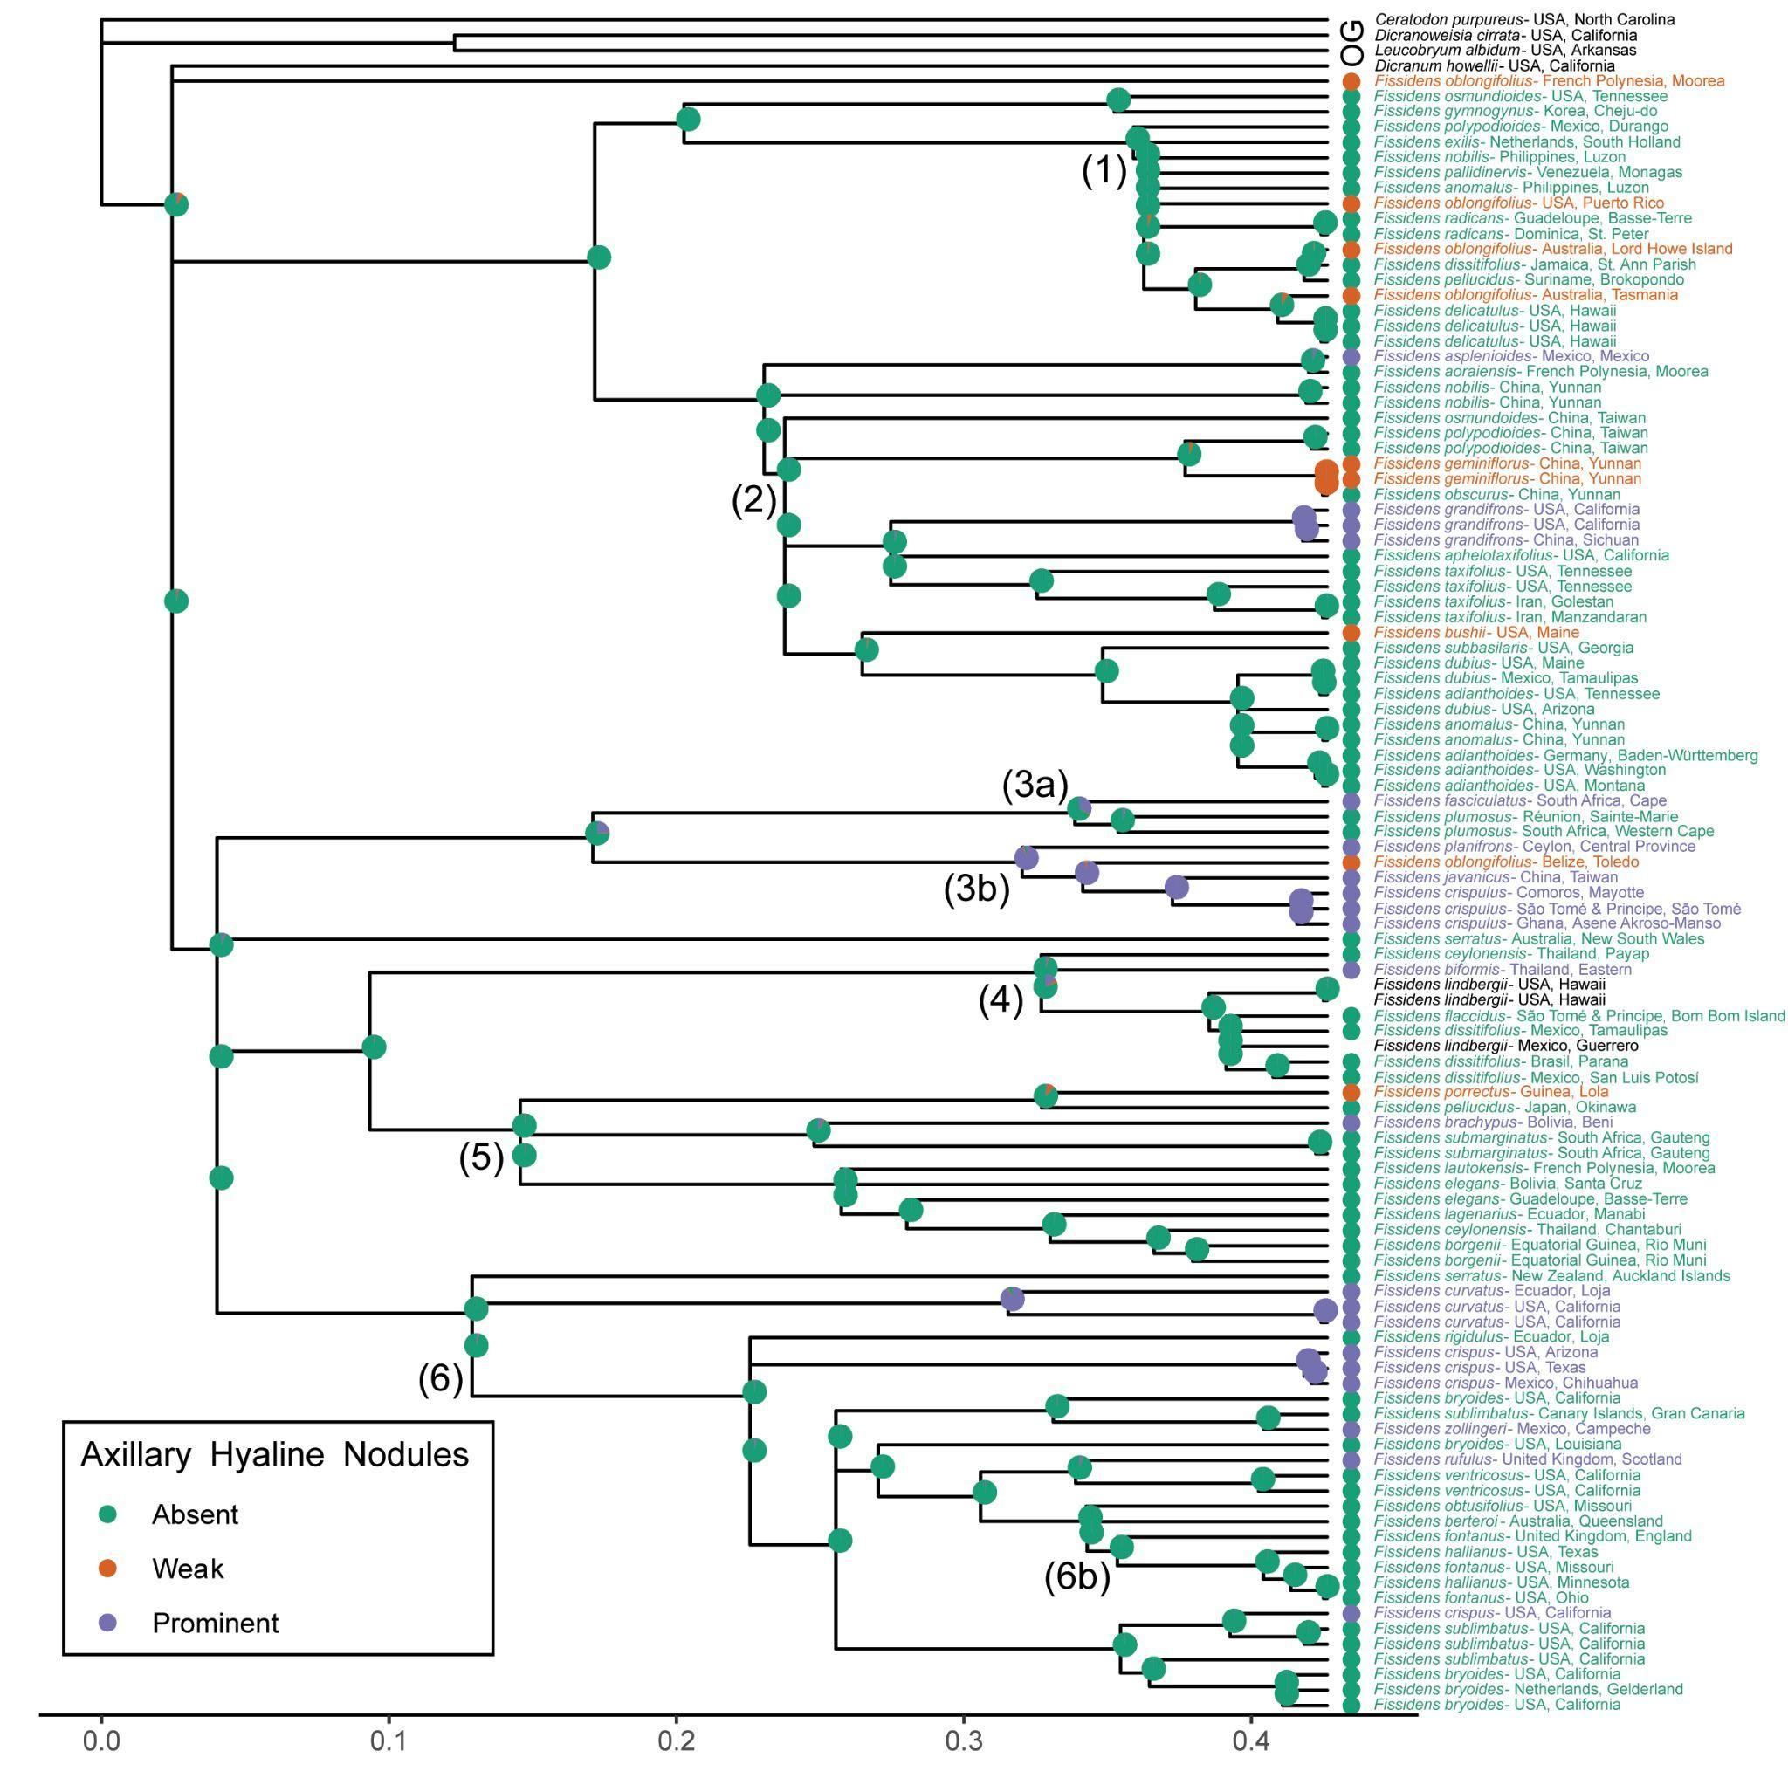
Fig. S7. Axillary hyaline nodule character states mapped onto the three-gene Fissidentaceae Bayesian inference majority rule consensus tree using maximum likelihood and an equal rates model. The probability of the states at each node is shown as pie charts representing the proportional likelihood values for each character state. The scale bar represents the number of substitutions per site. The legend indicates the color associated with each character state. Species with missing data are in black text. The major clades, which correspond to the numbered branches in Fig. 2, are indicated on the tree.
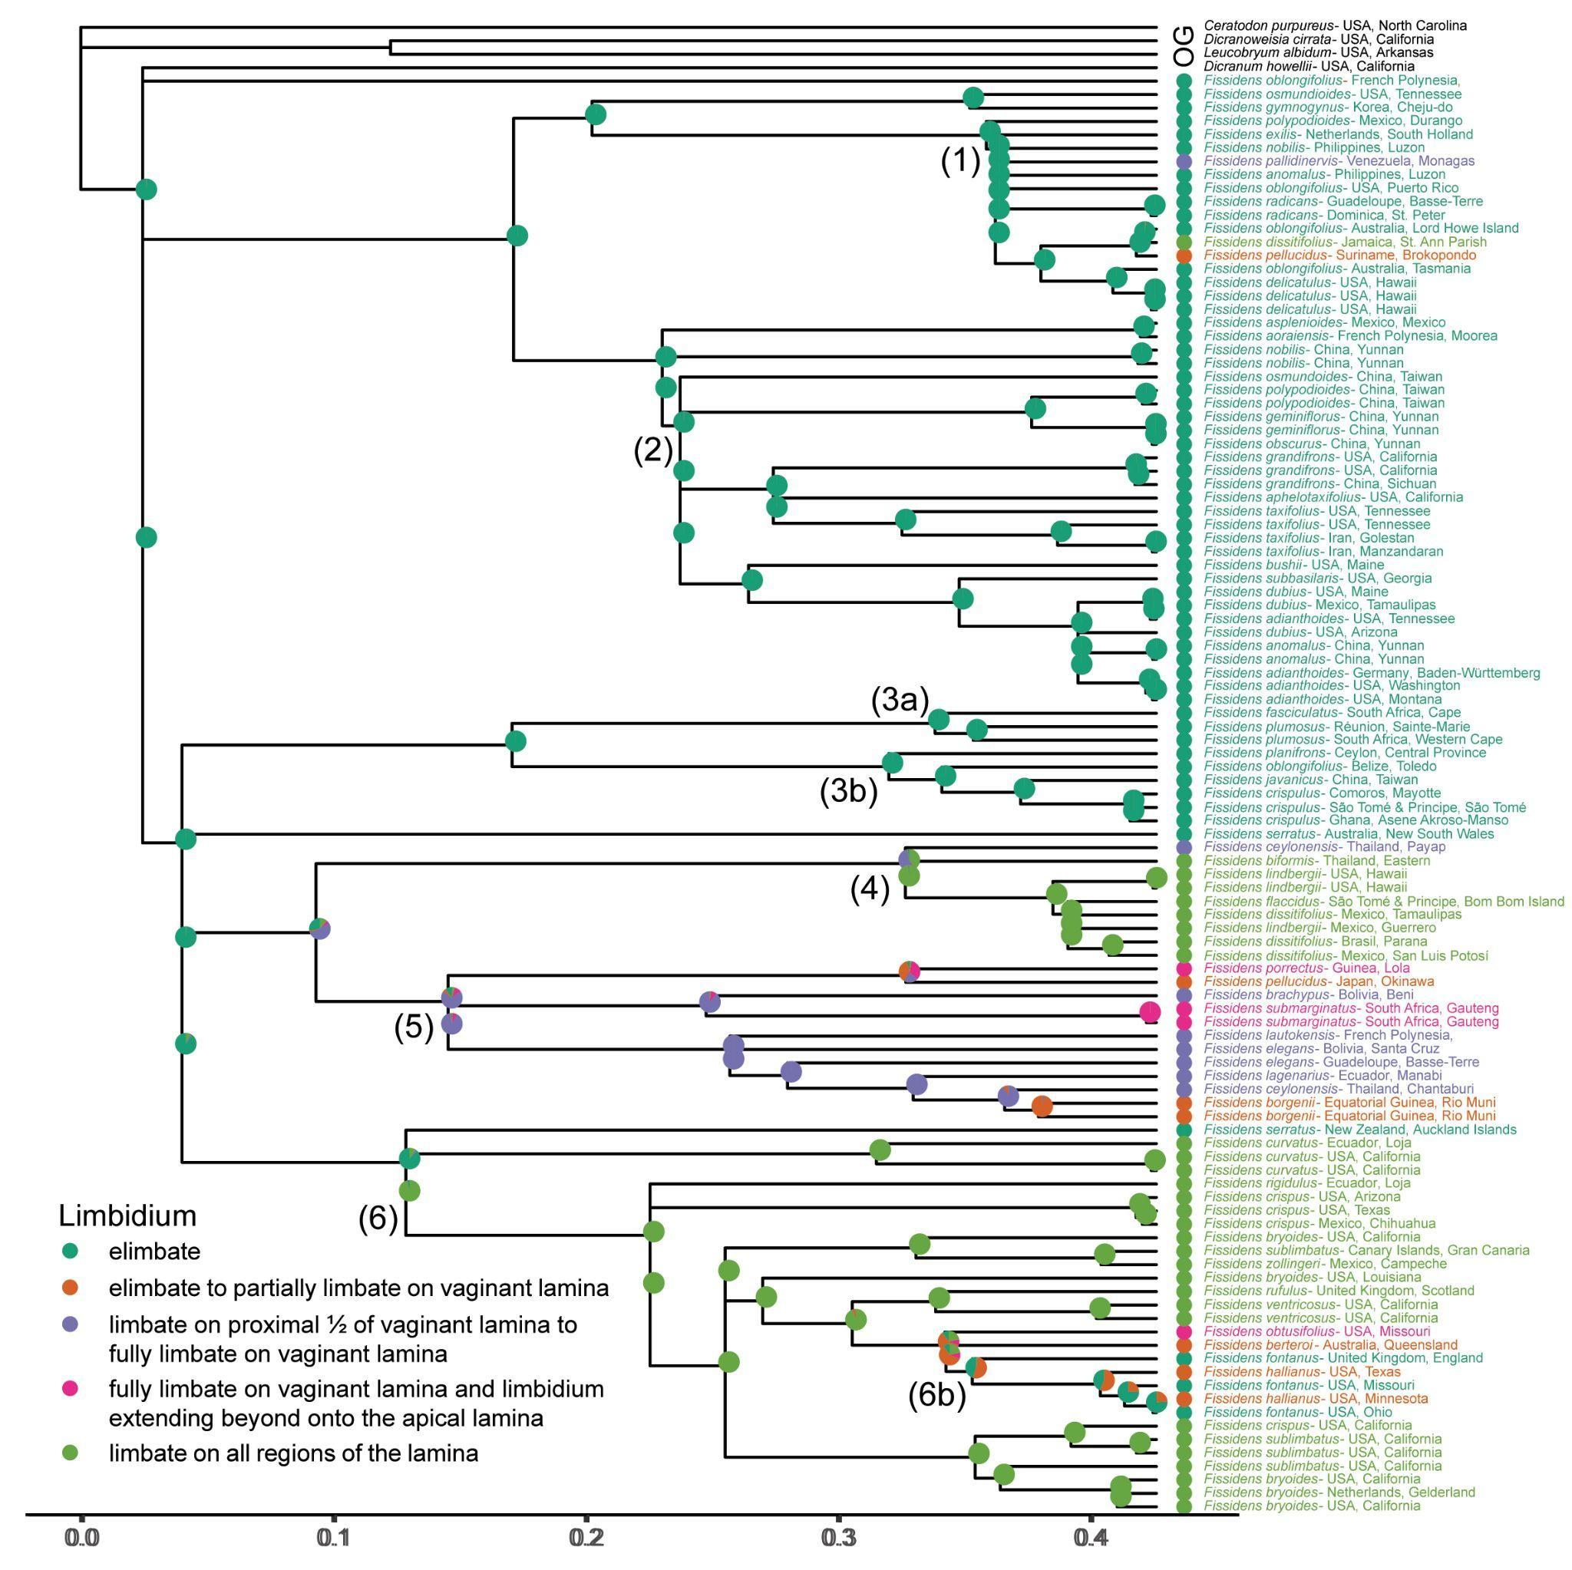
Fig. S8. Limbidium character states mapped onto the three-gene Fissidentaceae Bayesian inference majority rule consensus tree using maximum likelihood and an equal rates model. The probability of the states at each node is shown as pie charts representing the proportional likelihood values for each character state. The scale bar represents the number of substitutions per site. The legend indicates the color associated with each character state. Species with missing data are in black text. The major clades, which correspond to the numbered branches in Fig. 2, are indicated on the tree.
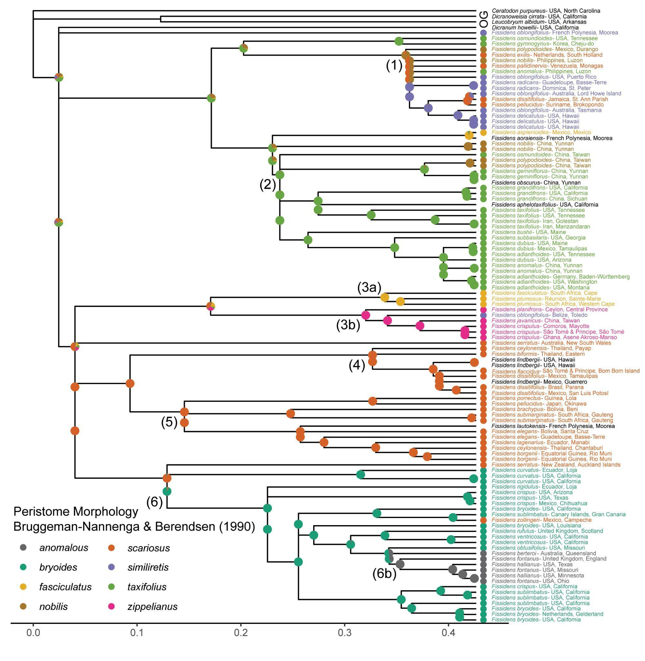
Fig. S9. Peristome morphology character states as defined by Bruggeman-Nannenga & Berendsen (1990) mapped onto the three-gene Fissidentaceae Bayesian inference majority rule consensus tree using maximum likelihood and an equal rates model. The probability of the states at each node is shown as pie charts representing the proportional likelihood values for each character state. The scale bar represents the number of substitutions per site. The legend indicates the color associated with each character state. Species with missing data are in black text. The major clades, which correspond to the numbered branches in Fig. 2, are indicated on the tree.
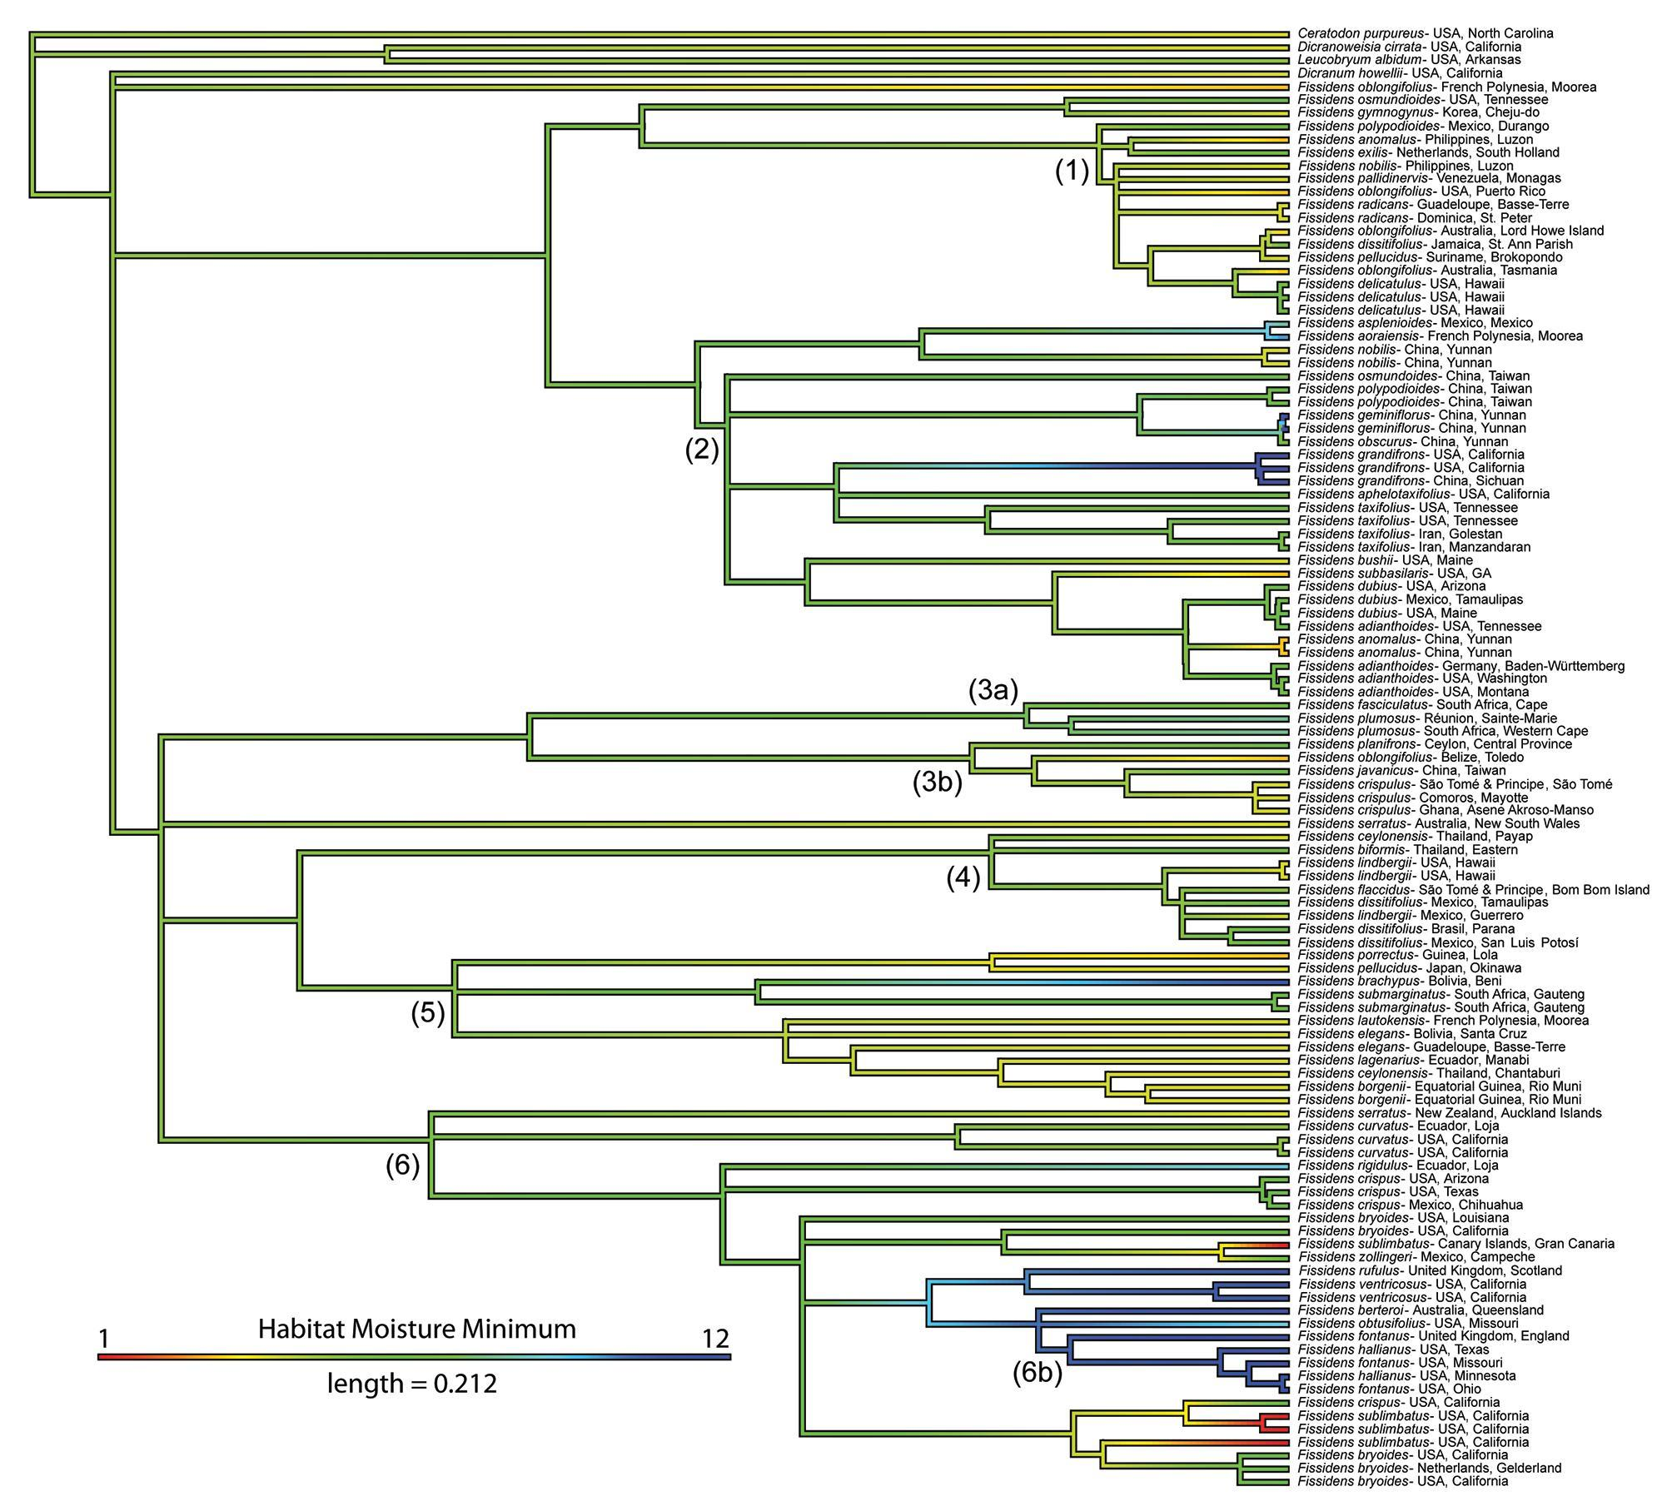
Fig. S10. Continuous character state mapping of the habitat moisture minimum, ranging from 1 (red) to 12 (blue), onto the three-gene Fissidentaceae Bayesian inference tree. The length of the colored scale bar represents the number of substitutions per site. The major clades, which correspond to the numbered branches in Fig. 2, are indicated on the tree.
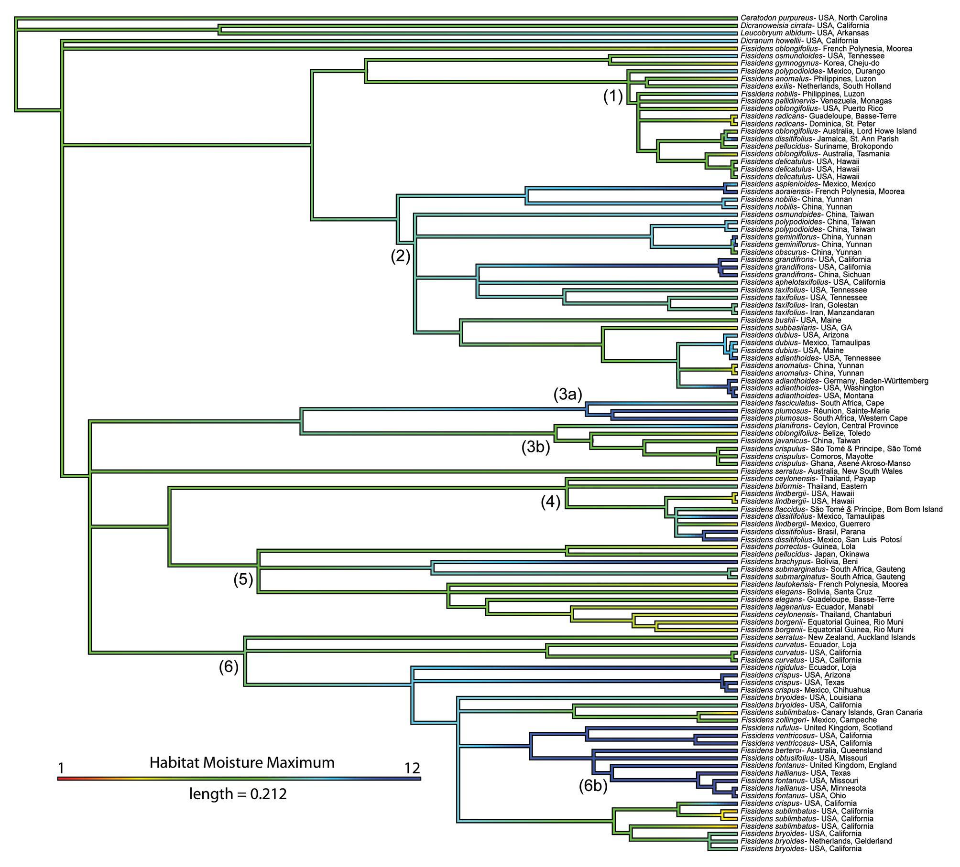

Fig. S11. Continuous character state mapping of the habitat moisture maximum, ranging from 1 (red) to 12 (blue), onto the three-gene Fissidentaceae Bayesian inference tree. The length of the colored scale bar represents the number of substitutions per site. The major clades, which correspond to the numbered branches in Fig. 2, are indicated on the tree.

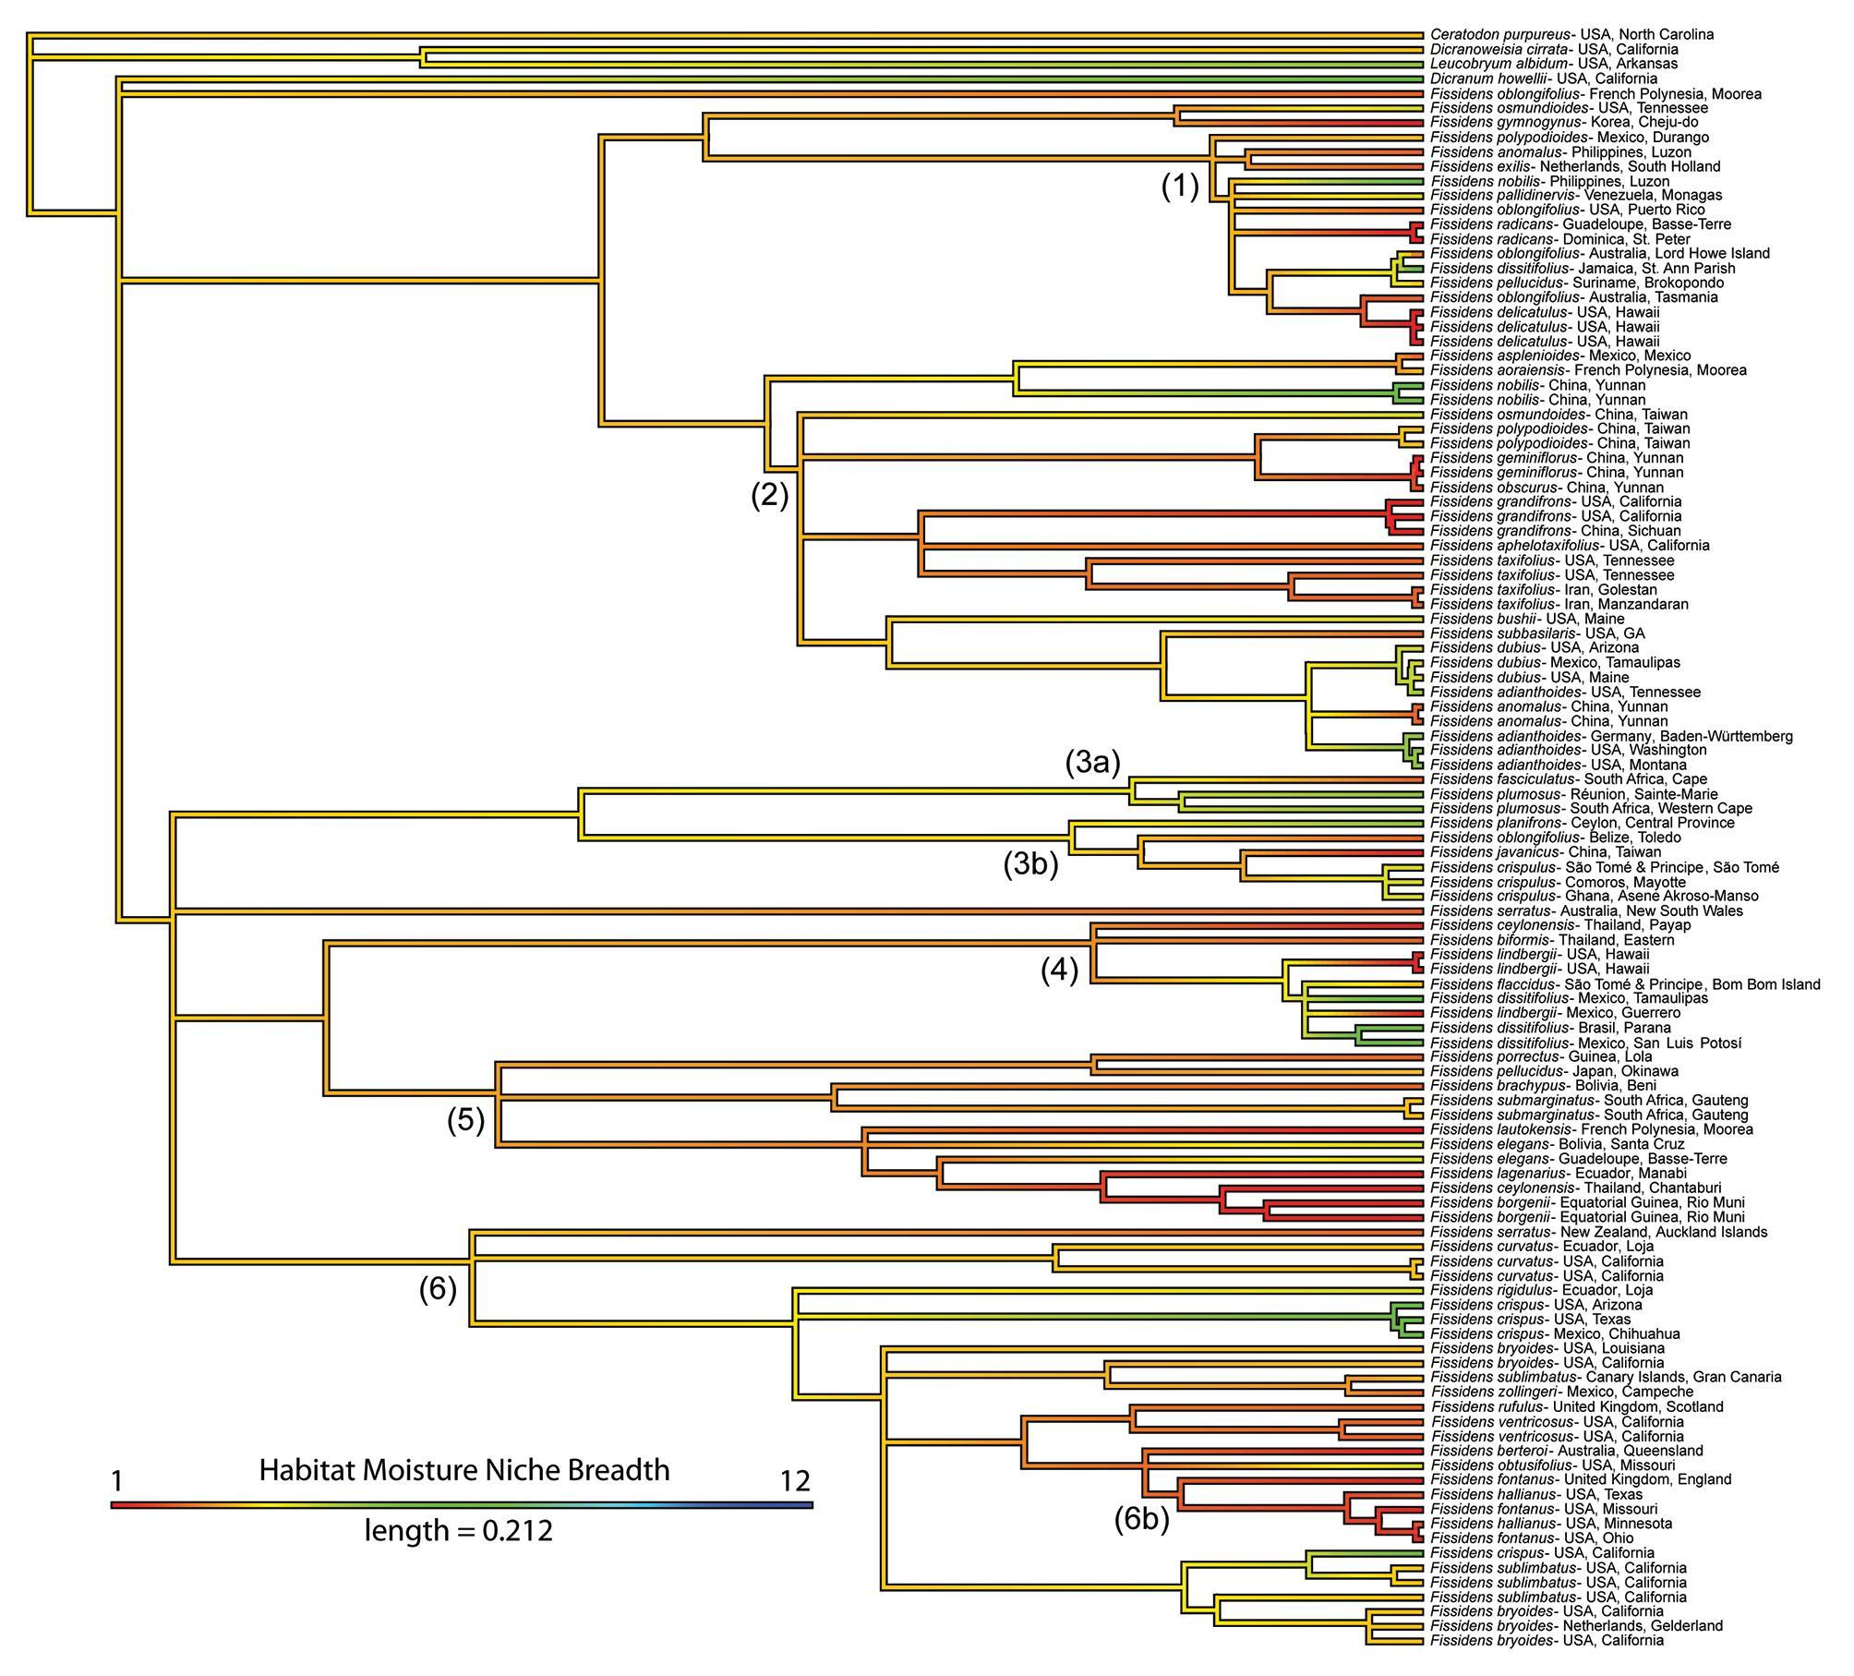
Fig. S12. Continuous character state mapping of the habitat moisture niche breadth, ranging from 1 (red) to 12 (blue), onto the three-gene Fissidentaceae Bayesian inference tree. The length of the colored scale bar represents the number of substitutions per site. The major clades, which correspond to the numbered branches in Fig. 2, are indicated on the tree.
Table S1. Herbarium specimens sampled for phylogenetic analyses.
 | Species | Authority | Herbarium Accession Number | Collector & Collection Number | Locality | Determined by | Genbank Accession Number GoFlag Data | Genbank Accession Number trnA | Genbank Accession Number trnL-F | Genbank Accession Number ITS2
GoFlag | Ceratodon purpureus | (Hedw.) Brid. | NYSi2774 | Miller, N.G. 18,934 | USA, New York | S.F. McDaniel | SAMN14888298 | NA | NA | NA
Three-gene | Ceratodon purpureus | (Hedw.) Brid. | TENN-B-0013173 | P.G. Davison s.n. | USA, North Carolina | D.K. Smith | NA | OL516465 | OL516362 | OL457714
Three-gene | Dicranoweisia cirrata | (Hedw.) Lindb. | TENN-B-0019070 | D.H. Norris 68366 | USA, California | D.H. Norris | NA | OL516466 | OL516363 | OL457713
GoFlag | Dicranum acutifolium | (Lindb. & Arnell) C.E.O. Jensen | FLAS | Moss Dimensions Team 394 | USA, Alaska | S.F. McDaniel | SAMN14888300 | NA | NA | NA
GoFlag | Dicranum elongatum | Schleich. ex Schwägr. | FLAS | Moss Dimensions Team 395 | USA, Alaska | S.F. McDaniel | SAMN14888301 | NA | NA | NA
GoFlag | Dicranum fragilifolium | Lindb. | FLAS | Moss Dimensions Team 396 | USA, Alaska | S.F. McDaniel | SAMN14888302 | NA | NA | NA
Three-gene | Dicranum howellii | Renauld & Cardot | DAV236939 | M. Berbee 15 | USA, California | S.P. Rae | NA | OL516468 | OL516365 | OL457715
GoFlag | Dicranum montanum | Hedw. | FLAS | Moss Dimensions Team 397 | USA, Alaska | S.F. McDaniel | SAMN14888303 | NA | NA | NA
GoFlag | Dicranum polysetum | Sw. | FLAS | Moss Dimensions Team 398 | USA, Alaska | S.F. McDaniel | SAMN14888304 | NA | NA | NA
GoFlag | Dicranum scoparium | Hedw. | FLAS | Moss Dimensions Team 399 | USA, Alaska | S.F. McDaniel | SAMN14888305 | NA | NA | NA
GoFlag | Dicranum undulatum | Schrad. ex Brid. | FLAS | Moss Dimensions Team 400 | USA, Alaska | S.F. McDaniel | SAMN14888306 | NA | NA | NA
GoFlag | Fissidens adianthoides | Hedw. | MO-6495516 | N.J. Holmberg 4722 | USA, Missouri | J.M. Budke | SRR17180445 | NA | NA | NA
Three-gene | Fissidens adianthoides | Hedw. | UC1721886 | D.H. Norris 90352 | USA, Washington | J.M. Budke | NA | OL516476 | OL516369 | OL457724
Three-gene | Fissidens adianthoides | Hedw. | UC1739115 | J.R. Shevock 15405 | USA, Montana | J.M. Budke | NA | OL516567 | OL516368 | NA
Three-gene | Fissidens adianthoides | Hedw. | TENN-B-0025613 | D.K. Smith & P.G. Davison 185 | USA, Tennessee | J.M. Budke | NA | OL516471 | OL516381 | OL457721
Three-gene | Fissidens adianthoides | Hedw. | MO-6690398 | Schäfer-Verwimp & Verwimp 35877 | Germany, Baden-Württemberg | J.M. Budke | NA | OL516473 | OL516366 | OL457725
GoFlag | Fissidens andicola | (Herzog) Brugg.-Nann. | MO-6363543 | S. Carreño & Y. Inturias 219 | Bolivia, Chuquisaca | S.P. Churchill | SRR17180444 | NA | NA | NA
Three-gene | Fissidens anomalus | Mont. | UC1933948 | J.R. Shevock 27246 | China, Yunnan | J.M. Budke | NA | OL516475 | OL516370 | OL457722
Three-gene | Fissidens anomalus | Mont. | TENN-B-0103458 | Z. Iwatsuki, A.J. Sharp, & E. Sharp 14173 | Philippines, Luzon | J.M. Budke | NA | NA | NA | OL457734
Three-gene & GoFlag | Fissidens anomalus | Mont. | UC1730411 | J.R. Shevock 31078 with D.G. Long & X. Fan | China, Yunnan | J.M. Budke | SRR17180433 | OL516474 | OL516371 | OL457723
Three-gene | Fissidens aoraiensis | H. Whittier & H.A. Mill. | UC1773059 | D.P. Wall 434 | French Polynesia, Moorea | J.M. Budke | NA | OL516505 | OL516417 | OL457785
Three-gene | Fissidens aphelotaxifolius | R.A. Pursell | UC1741874 | J.R. Shevock 20225 with D. Norris, C. Beyer, & M. Price | USA, California | J.M. Budke | NA | OL516482 | OL516377 | OL457727
GoFlag | Fissidens asplenioides | Hedw. | MO-6625638 | R.R. Ireland & G. Bellolio 35749 | Chile, Bíobío | J.M. Budke | SRR17180422 | NA | NA | NA
Three-gene | Fissidens asplenioides | Hedw. | UC1779379 | A. Cardenas S. 3208 | Mexico, Mexico | J.M. Budke | NA | OL516489 | OL516386 | OL457728
Three-gene | Fissidens berterii | (Mont.) Müll. Hal. | MO-6692035 | D.H. Norris 35417 | Australia, Queensland | J.M. Budke | NA | OL516541 | OL516448 | OL457762
Three-gene | Fissidens biformis | Mitt. | ALTA046086 | Larsen, Santisuk, & Warncke 3283 | Thailand, Eastern | S. He | NA | OL516520 | OL516437 | NA
Three-gene | Fissidens borgenii | Hampe | UC1944532 | D.H. Norris 106036 with P. Heras & M. Infante | Equatorial Guinea, Rio Muni | J.M. Budke | NA | OL516512 | OL516420 | OL457787
Three-gene | Fissidens borgenii | Hampe | UC1944527 | D.H. Norris 105853 with P. Heras & M. Infante | Equatorial Guinea, Rio Muni | J.M. Budke | NA | OL516513 | OL516421 | OL457788
Three-gene | Fissidens brachypus | Mitt. | MO-6094962 | D. Rocabado & E. Calzadilla 1005 | Bolivia, Beni | S.P. Churchill | NA | OL516507 | OL516428 | OL457794
Three-gene | Fissidens bryoides | Hedw. | UC1771471 | M.J. Lenz 611 | USA, California | J.M. Budke | NA | OL516543 | OL516463 | OL457769
Three-gene | Fissidens bryoides | Hedw. | UC1712650 | J.R. Shevock 16855 with D. Norris | USA, California | J.M. Budke | NA | OL516502 | NA | OL457774
Three-gene | Fissidens bryoides | Hedw. | UC1782678 | J.R. Shevock 24824 with K. Kellman | USA, California | J.M. Budke | NA | OL516536 | OL516449 | OL457772
Three-gene | Fissidens bryoides | Hedw. | MO-6695707 | R.A. Pursell et al. 12273 | Netherlands, Gelderland | J.M. Budke | NA | OL516534 | OL516462 | OL457773
Three-gene | Fissidens bryoides | Hedw. | MO-6695706 | R.A. Pursell & B. Allen 12240 | USA, Louisiana | J.M. Budke | NA | OL516542 | OL516441 | OL457809
Three-gene | Fissidens bushii | (Cardot & Thér.) Cardot & Thér. | UC1918190 | D.H. Norris 109180 & N. Hillyard | USA, Maine | D.H. Norris | NA | OL516477 | OL516372 | OL457726
Three-gene | Fissidens ceylonensis | Dozy & Molk. | ALTA044970 | K. Larsen, T. Smitinand, & E. Warncke 1697 | Thailand, Chantaburi | J.M. Budke | NA | OL516506 | OL516397 | OL457786
Three-gene | Fissidens ceylonensis | Dozy & Molk. | ALTA044969 | A. Touw 9415 | Thailand, Payap | J.M. Budke | NA | OL516565 | OL516419 | OL457795
GoFlag | Fissidens crispulus | Brid. | MO-6621342 | S. He 44264 | Laos, Luang Namtha | J.M. Budke | SRR17180411 | NA | NA | NA
Three-gene | Fissidens crispulus | Brid. | MO-3992381 | R.E. Magill & T. Pócs 11592 | Comoros, Mayotte | R.A. Pursell | NA | OL516499 | OL516409 | NA
Three-gene | Fissidens crispulus | Brid. | MO-6695510 | J.R. Shevock & M. Nadel 40092 | São Tomé & Principe, São Tomé | R.A. Pursell | NA | OL516497 | OL516410 | NA
Three-gene | Fissidens crispulus | Brid. | E00848203 | G. Ameka 213 | Ghana, Asene Akroso-Manso | J.M. Budke | NA | NA | OL516411 | NA
GoFlag | Fissidens crispus | Mont. | MO-6490634 | B. Allen 30710 | Guinea, Lola | J.M. Budke | SRR17180406 | NA | NA | NA
Three-gene | Fissidens crispus | Mont. | UC1739497 | J.R. Shevock 19175 | USA, California | J.M. Budke | NA | OL516539 | OL516454 | OL457775
Three-gene | Fissidens crispus | Mont. | UC1797946 | J.R. Shevock 29566 with K. Kellman | USA, Arizona | J.M. Budke | NA | OL516544 | OL516460 | OL457807
Three-gene | Fissidens crispus | Mont. | TENN-B-0026854 | R.E. Magill 255 | USA, Texas | J.M. Budke | NA | NA | NA | OL457806
Three-gene | Fissidens crispus | Mont. | TENN-B-0064064 | F.D. Bowers, C. Delgadillo M., & P. Somers Jr. 5346-a | Mexico, Chihuahua | J.M. Budke | NA | OL516556 | OL516459 | OL457805
Three-gene | Fissidens curvatus | Hornsch. | UC1920833 | D.H. Norris 92591 with M. Aguirre & M. Bolívar | Ecuador, Loja | D.H. Norris | NA | OL516531 | OL516442 | OL457808
Three-gene | Fissidens curvatus | Hornsch. | UC1739990 | J.R. Shevock 18886 | USA, California | R.A. Pursell | NA | OL516529 | OL516443 | OL457782
Three-gene | Fissidens curvatus | Hornsch. | UC1917777 | D.H. Norris 109575 with N.M. Hillyard | USA, California | D.H. Norris | NA | OL516530 | OL516444 | OL457783
GoFlag | Fissidens cuynetii | Bizot | MO-6490650 | B. Allen 30731 | Guinea, Lola | R.A. Pursell | SRR17180405 | NA | NA | NA
GoFlag | Fissidens dasyphus | Welw. & Duby | MO-6369667 | B. Allen 30850 | Gabon, Moyen-Ogooué | R.A. Pursell | SRR17180404 | NA | NA | NA
Three-gene | Fissidens delicatulus | Ångström | ALTA045117 | D.H. Vitt 14523 | USA, Hawaii | D.H. Vitt | NA | OL516564 | OL516399 | OL457738
Three-gene | Fissidens delicatulus | Ångström | ALTA045120 | W.J. Hoe 2303 | USA, Hawaii | J.M. Budke | NA | OL516562 | OL516398 | OL457739
Three-gene | Fissidens delicatulus | Ångström | ALTA045119 | D.H. Vitt 8151 | USA, Hawaii | J.M. Budke | NA | OL516563 | OL516400 | OL457740
GoFlag | Fissidens dissitifolius | Sull. | MO-5922779 | S.P. Churchill et al. 21268 | Bolivia, Nuflo de Chavez | J.M. Budke | SRR17180403 | NA | NA | NA
GoFlag | Fissidens dissitifolius | Sull. | MO-5270945 | B. Allen 25557 | Suriname, Sipaliwini | J.M. Budke | SRR17180402 | NA | NA | NA
Three-gene | Fissidens dissitifolius | Sull. | ALTA045125 | W.R. Buck 5993 | Jamaica, St. Ann Parish | J.M. Budke | NA | OL516560 | OL516434 | NA
Three-gene | Fissidens dissitifolius | Sull. | ALTA045124 | D.H. Vitt 21321 | Brasil, Parana | J.M. Budke | NA | OL516523 | OL516435 | OL457800
Three-gene | Fissidens dissitifolius | Sull. | TENN-B-0063839 | A.J. Sharp 8762 | Mexico, Tamaulipas | J.M. Budke | NA | OL516528 | OL516430 | OL457799
Three-gene | Fissidens dissitifolius | Sull. | TENN-B-0063848 | F.D. Bowers, D. Bowers, & P. Somers, Jr. 5021 | Mexico, San Luis Potosí | J.M. Budke | NA | OL516521 | OL516436 | OL457802
GoFlag | Fissidens dubius | P. Beauv. | MO-6232211 | J.R. Shevock 35362 with Y.-X. Xiong & L. Zhang | China, Guizhou | R.A. Pursell | SRR17180443 | NA | NA | NA
Three-gene | Fissidens dubius | P. Beauv. | UC1917397 | D.H. Norris 109275 & N. Hillyard | USA, Maine | J.M. Budke | NA | OL516469 | OL516383 | OL457720
Three-gene | Fissidens dubius | P. Beauv. | UC1797935 | J.R. Shevock 29708 with N. Miller, W. Schofield, K. Kellman, & B. Shaw | USA, Arizona | J.M. Budke | NA | OL516470 | OL516384 | OL457717
Three-gene | Fissidens dubius | P. Beauv. | TENN-B-0063816 | D.K. Smith 279 with A.J. Sharp, E. Sharp, S. Nakanishi, M. Manuel, & H.J. Webster | Mexico, Tamaulipas | J.M. Budke | NA | NA | OL516382 | OL457719
GoFlag | Fissidens elegans | Brid. | MO-6692356 | R.A. Pursell 12387 | USA, Georgia | R.A. Pursell | SRR17180442 | NA | NA | NA
Three-gene | Fissidens elegans | Brid. | MO-6499845 | Y. Inturias et al. 729A | Bolivia, Santa Cruz | J.M. Budke | NA | OL516509 | OL516425 | OL457792
Three-gene | Fissidens elegans | Brid. | ALTA045160 | B. Goffinet 2504 | Guadeloupe, Basse-Terre | R.A. Pursell | NA | OL516510 | OL516424 | OL457791
Three-gene | Fissidens exilis | Hedw. | TENN-B-0103453 | N.E. Nannenga-Bremekamp s.n. | Netherlands, South Holland | J.M. Budke | NA | OL516522 | NA | OL457735
Three-gene | Fissidens fasciculatus | Hornsch. | ALTA045176 | T. Arts s.n. | South Africa, Cape | T. Arts | NA | OL516503 | OL516415 | OL457761
GoFlag | Fissidens flaccidus | Mitt. | MO-6629427 | W.D. Stevens & O.M. Montiel 35465 | Nicaragua, Nueva Segovia | B. Allen | SRR17180441 | NA | NA | NA
Three-gene | Fissidens flaccidus | Mitt. | MO-6695514 | J.R. Shevock 40003 | São Tomé & Principe, Bom Bom Island | R.A. Pursell | NA | OL516526 | OL516433 | OL457801
GoFlag | Fissidens fontanus | (Bach. Pyl.) Steud. | MO-6495774 | N.J. Holmberg 4351 | USA, Missouri | J.M. Budke | SRR17180440 | NA | NA | NA
GoFlag | Fissidens fontanus | (Bach. Pyl.) Steud. | MO-6497233 | K. Cezón, J. Muñoz, T. Delgado s.n. | Portugal, Vila Real | J.M. Budke | SRR17180439 | NA | NA | NA
Three-gene | Fissidens fontanus | (Bach. Pyl.) Steud. | ALTA045184 | J.A. Snider & S. He 3615 | USA, Ohio | J.M. Budke | NA | OL516548 | OL516458 | OL457765
Three-gene | Fissidens fontanus | (Bach. Pyl.) Steud. | ALTA045182 | B. Allen & P.L. Redfearn Jr. 55 | USA, Missouri | B. Allen & P.L. Redfearn Jr. | NA | OL516550 | OL516457 | OL457763
Three-gene | Fissidens fontanus | (Bach. Pyl.) Steud. | E00848207 | C.C. Townsend 95/147 | United Kingdom, England | J.M. Budke | NA | NA | NA | OL457766
GoFlag | Fissidens geminiflorus | Dozy & Molk. | MO-6232218 | J.R. Shevock 35100 with Y.-X. Xiong & L. Zhang | China, Guizhou | R.A. Pursell | SRR17180438 | NA | NA | NA
Three-gene | Fissidens geminiflorus | Dozy & Molk. | UC1933929 | J.R. Shevock 30846 with D.G. Long & X. Fan | China, Yunnan | R.A. Pursell | NA | OL516492 | OL516389 | OL457749
Three-gene | Fissidens geminiflorus | Dozy & Molk. | UC1921017 | J.R. Shevock 25342 with X. Fan | China, Yunnan | R.A. Pursell | NA | OL516493 | OL516390 | OL457750
GoFlag | Fissidens grandifrons | Brid. | MO-6491855 | J.C. Brinda 4331 | USA, Missouri | J.M. Budke | SRR17180437 | NA | NA | NA
Three-gene | Fissidens grandifrons | Brid. | UC1739802 | J.R. Shevock 19440 with B. Ertter | USA, California | J.R. Shevock | NA | OL516480 | OL516380 | OL457752
Three-gene | Fissidens grandifrons | Brid. | UC1739308 | J.R. Shevock 20115 with D. Toren | USA, California | J.M. Budke | NA | OL516481 | OL516378 | OL457753
Three-gene | Fissidens grandifrons | Brid. | MO-6628341 | J.R. Shevock 36240 with D. Boufford & J. Yue | China, Sichuan | J.R. Shevock | NA | OL516479 | OL516379 | OL457754
Three-gene | Fissidens gymnogynus | Besch. | UC1712146 | J.R. Shevock 16386 | Korea, Cheju-do | J.M. Budke | NA | OL516491 | OL516388 | OL457758
Three-gene | Fissidens hallianus | (Sull. & Lesq.) Mitt. | ALTA045337 | J.B. Mayle 3334 | USA, Minnesota | J.M. Budke | NA | OL516549 | OL516455 | OL457764
Three-gene | Fissidens hallianus | (Sull. & Lesq.) Mitt. | TENN-B-0026472 | F.A. Barkley 13332 | USA, Texas | J.M. Budke | NA | OL516553 | OL516456 | NA
GoFlag | Fissidens involutus | Wilson ex Mitt. | MO-6232222 | J.R. Shevock 35579 with T. J.-D. Yang & K.-Y. Yao | China, Taiwan | R.A. Pursell | SRR17180436 | NA | NA | NA
Three-gene | Fissidens javanicus | Dozy & Molk. | MO-6492273 | J.R. Shevock 41657 with T. J.-D. Yang | China, Taiwan | J.M. Budke | NA | OL516500 | OL516412 | NA
GoFlag | Fissidens jungermannioides | Griff. | MO-6493106 | J.R. Shevock 41662 with T. J.-D. Yang | China, Taiwan | J.M. Budke | SRR17180435 | NA | NA | NA
Three-gene | Fissidens lagenarius var. muriculatus | (Spruce ex Mitt.) Pursell | UC1721770 | D.H. Norris 85728 & E. Barahona M. | Ecuador, Manabi | J.M. Budke | NA | OL516514 | NA | NA
Three-gene | Fissidens lautokensis | Dixon | UC1772804 | D.P. Wall 76 | French Polynesia, Moorea | D.P. Wall | NA | OL516511 | OL516422 | OL457793
Three-gene | Fissidens lindbergii | Mitt. | ALTA045107 | D.H. Vitt 14687 | USA, Hawaii | D.H. Vitt | NA | OL516524 | OL516431 | OL457796
Three-gene | Fissidens lindbergii | Mitt. | ALTA045109 | W.J. Hoe & L.E. Bishop 287 | USA, Hawaii | J.M. Budke | NA | OL516525 | OL516432 | OL457797
Three-gene | Fissidens lindbergii | Mitt. | MO-6695761 | R.A. Pursell 11534 | Mexico, Guerrero | R.A. Pursell | NA | OL516527 | OL516429 | OL457798
GoFlag | Fissidens microcarpus | Mitt. | MO-6369647 | B. Allen 31014 | Gabon, Moyen-Ogooué | J.M. Budke | SRR17180434 | NA | NA | NA
GoFlag | Fissidens nobilis | Griff. | MO-6492272 | J.R. Shevock 41420 | China, Taiwan | J.M. Budke | SRR17180432 | NA | NA | NA
GoFlag | Fissidens nobilis | Griff. | MO-6624709 | J.R. Shevock 43462 with M.A. Wenzhang & Y.A.O. Yuanlin | China, Yunnan | J.M. Budke | SRR17180431 | NA | NA | NA
Three-gene | Fissidens nobilis | Griff. | UC1933938 | J.R. Shevock 28511 | China, Yunnan | J.M. Budke | NA | OL516486 | OL516394 | OL457755
Three-gene | Fissidens nobilis | Griff. | UC1933944 | J.R. Shevock 28008 | China, Yunnan | J.M. Budke | NA | OL516487 | OL516395 | OL457756
Three-gene | Fissidens nobilis | Griff. | TENN-B-0103461 | Z. Iwatsuki, AJ. Sharp, & E. Sharp 14065 | Philippines, Luzon | J.M. Budke | NA | OL516555 | NA | OL457732
GoFlag | Fissidens oblongifolius | Hook. f. & Wilson | MO-6368004 | W.R. Buck 57880 | Australia, Tasmania | J.M. Budke | SRR17180430 | NA | NA | NA
Three-gene | Fissidens oblongifolius | Hook. f. & Wilson | ALTA045485 | D.H. Vitt 29096 | Australia, Tasmania | J.M. Budke | NA | OL516535 | OL516404 | OL457743
Three-gene | Fissidens oblongifolius | Hook. f. & Wilson | UC1778270 | T.D. d'Artenay 76 | French Polynesia, Moorea | J.M. Budke | NA | OL516561 | OL516401 | OL457741
Three-gene | Fissidens oblongifolius | Hook. f. & Wilson | ALTA045475 | D.H. Vitt 28387 with H. Ramsay | Australia, Lord Howe Island | J.M. Budke | NA | OL516559 | OL516403 | OL457742
Three-gene | Fissidens oblongifolius | Hook. f. & Wilson | MO-4415472 | B. Allen 18637 | Belize, Toledo | J.M. Budke | NA | OL516498 | OL516408 | NA
Three-gene | Fissidens oblongifolius | Hook. f. & Wilson | MO-5139611 | M.J. Price 903 | USA, Puerto Rico | J.M. Budke | NA | OL516557 | OL516405 | OL457730
GoFlag | Fissidens obscurus | Mitt. | MO-6624582 | J.R. Shevock 43276 with M.A. Wenzhang, Y.A.O. Yuanlin, & F.A.N. Zuezhong | China, Yunnan | J.M. Budke | SRR17180429 | NA | NA | NA
Three-gene | Fissidens obscurus | Mitt. | UC1782823 | J.R. Shevock 23321 | China, Yunnan | J.M. Budke | NA | OL516494 | OL516391 | OL457751
Three-gene | Fissidens obtusifolius | Wilson | MO-6368560 | N.J. Holmberg 4303 | USA, Missouri | J.M. Budke | NA | OL516547 | OL516447 | OL457770
GoFlag | Fissidens oediloma | Müll. Hal. ex Broth. | MO-5234010 | S.P. Churchill et al. 20265 | Paraguay, Paraguarí | R.A. Pursell | SRR17180428 | NA | NA | NA
GoFlag | Fissidens osmundioides | Hedw. | MO-6629453 | B. Allen 31522A | USA, Maine | J.M. Budke | SRR17180427 | NA | NA | NA
Three-gene | Fissidens osmundioides | Hedw. | UC1739394 | J.R. Shevock 18260 with L. Shu-Hong & L. Kwo-Shang | China, Taiwan | J.M. Budke | NA | OL516488 | OL516385 | OL457729
Three-gene | Fissidens osmundioides | Hedw. | TENN-B-0025632 | K.C. Bowman 178 | USA, Tennessee | J.M. Budke | NA | OL516490 | OL516387 | OL457757
GoFlag | Fissidens ovatus | Brid. | MO-5261849 | C. Birkinshaw 800 | Madagascar, Antsiranana | J.M. Budke | SRR17180426 | NA | NA | NA
GoFlag | Fissidens pallidinervis | Mitt. | MO-5234020 | S.P. Churchill et al. 20285 | Paraguay, Paraguarí | R.A. Pursell | SRR17180425 | NA | NA | NA
Three-gene | Fissidens pallidinervis | Mitt. | TENN-B-0103449 | R.A. Pursell 8329 | Venezuela, Monagas | J.M. Budke | NA | NA | NA | OL457733
GoFlag | Fissidens palmifolius | (P. Beauv.) Broth. | MO-6095542 | N. Fernsby CH13856 | South Africa, Gauteng | J.M. Budke | SRR17180424 | NA | NA | NA
Three-gene | Fissidens pellucidus | Hornsch. | ALTA045442 | M. Mizutani & I. Yoshimura 1269 | Japan, Okinawa | J.M. Budke | NA | OL516501 | OL516402 | NA
Three-gene | Fissidens pellucidus | Hornsch. | ALTA045177 | J. Florschütz & P.A. Florschütz 4653 | Suriname, Brokopondo | J.M. Budke | NA | OL516516 | OL516418 | OL457804
GoFlag | Fissidens perdecurrens | Besch. | MO-6005386 | M.R. Crosby 15991 | China, Guizhou | B.C. Tan | SRR17180423 | NA | NA | NA
GoFlag | Fissidens perfalcatus | Broth. | MO-6369918 | B. Allen 30298 | Guinea, Lola | R.A. Pursell | SRR17180421 | NA | NA | NA
Three-gene | Fissidens planifrons | Besch. | E00848184 | C.C. Townsend 73/727 | Ceylon, Central Province | J.M. Budke | NA | NA | OL516416 | NA
Three-gene | Fissidens plumosus | Hornsch. | L-3962898 | M.A. Bruggeman-Nannenga 10954 | Réunion, Sainte-Marie | M.A. Bruggeman-Nannenga | NA | NA | OL516413 | OL457759
Three-gene | Fissidens plumosus | Hornsch. | MO-5368112 | T.A.J. Hedderson 15377 | South Africa, Western Cape | T.A.J. Hedderson | NA | NA | OL516414 | OL457760
GoFlag | Fissidens polyphyllus | Wilson ex B.S.G. | MO-6362261 | M.J. Cano 6276 | Spain, Asturias | J.M. Budke | SRR17180420 | NA | NA | NA
GoFlag | Fissidens polypodioides | Hedw. | MO-6492747 | R.E. Magill 14666 | Nicaragua, Nueva Segovia | J.M. Budke | SRR17180419 | NA | NA | NA
Three-gene | Fissidens polypodioides | Hedw. | UC1739895 | J.R. Shevock 17912 with L. Shu-Hong & L. Kwo-Shang | China, Taiwan | J.M. Budke | NA | OL516495 | OL516392 | OL457747
Three-gene | Fissidens polypodioides | Hedw. | UC1739460 | J.R. Shevock 18170 with L. Shu-Hong & L. Kwo-Shang | China, Taiwan | J.M. Budke | NA | OL516496 | OL516393 | OL457748
Three-gene | Fissidens polypodioides | Hedw. | TENN-B-0063987 | A.J. Sharp et al. 2873 | Mexico, Durango | J.M. Budke | NA | OL516483 | OL516396 | OL457731
GoFlag | Fissidens porrectus | Mitt. | MO-6495458 | J. Atwood 2259 | Gabon, Moyen-Ogooué | J.M. Budke | SRR17180418 | NA | NA | NA
Three-gene | Fissidens porrectus | Mitt. | MO-6490696 | B. Allen 30394 | Guinea, Lola | J.M. Budke | NA | OL516508 | OL516423 | OL457803
Three-gene | Fissidens radicans | Mont. | ALTA045790 | B. Goffinet 2645 | Dominica, St. Peter | R.A. Pursell | NA | OL516558 | OL516406 | OL457737
Three-gene | Fissidens radicans | Mont. | ALTA045789 | B. Goffinet 2819 | Guadeloupe, Basse-Terre | R.A. Pursell | NA | OL516566 | OL516407 | OL457736
Three-gene | Fissidens rigidulus | Hook. f. & Wilson | UC1943862 | D.H. Norris 91268 & J. Flanagan | Ecuador, Loja | D.H. Norris | NA | OL516532 | OL516461 | OL457781
Three-gene | Fissidens rufulus | Schimp. | E00848216 | D.G. Long 23053 | United Kingdom, Scotland | D.G. Long | NA | OL516554 | OL516464 | OL457771
GoFlag | Fissidens semicompletus | Hedw. | MO-6098210 | C. Aldana & N. Sanjines 806 | Bolivia, Sajama | J.M. Budke | SRR17180417 | NA | NA | NA
Three-gene | Fissidens serratus | Müll. Hal. | ALTA046048 | D.H. Vitt 9086 | New Zealand, Auckland Islands | J.M. Budke | NA | NA | OL516439 | OL457784
Three-gene | Fissidens serratus | Müll. Hal. | ALTA046047 | H. Streimann 5189 | Australia, New South Wales | J.M. Budke | NA | OL516533 | OL516440 | NA
GoFlag | Fissidens serrulatus | Brid. | MO-5646125 | M.J. Cano 1340 | Portugal, Madeira | J.M. Budke | SRR17180416 | NA | NA | NA
GoFlag | Fissidens subbasilaris | Hedw. | MO-6690782 | D.D. Davis 1229 | USA, Pennsylvania | J.M. Budke | SRR17180415 | NA | NA | NA
Three-gene | Fissidens subbasilaris | Hedw. | UC1775866 | D.H. Norris 108672 & N. Hillyard | USA, Georgia | J.M. Budke | NA | OL516472 | OL516367 | OL457718
Three-gene | Fissidens sublimbatus | Grout | UC1932112 | K.M. Kellman 2165 | USA, California | J.M. Budke | NA | OL516540 | OL516450 | OL457778
Three-gene | Fissidens sublimbatus | Grout | UC1932111 | K.M. Kellman 1364 | USA, California | J.M. Budke | NA | OL516537 | OL516445 | OL457776
Three-gene | Fissidens sublimbatus | Grout | UC1944357 | D.H. Norris 102283 with C. Bratt | USA, California | D.H. Norris | NA | OL516538 | OL516446 | OL457777
Three-gene | Fissidens sublimbatus | Grout | MO-6695518 | F. Müller 39626 | Canary Islands, Gran Canaria | J.M. Budke | NA | OL516551 | OL516451 | OL457779
Three-gene | Fissidens submarginatus | Bruch | ALTA045927 | J. van Rooy 2101 | South Africa, Gauteng | J.M. Budke | NA | OL516517 | OL516426 | OL457789
Three-gene | Fissidens submarginatus | Bruch | ALTA045925 | J. van Rooy 2187 | South Africa, Gauteng | J.M. Budke | NA | OL516518 | OL516427 | OL457790
GoFlag | Fissidens taxifolius | Hedw. | MO-6690778 | D.D. Davis 1225 | USA, Pennsylvania | B. Allen | SRR17180414 | NA | NA | NA
Three-gene | Fissidens taxifolius | Hedw. | TENN-B-0025962 | P.G. Davison & D.K. Smith 329 | USA, Tennessee | J.M. Budke | NA | OL516478 | OL516374 | NA
Three-gene | Fissidens taxifolius | Hedw. | UC1920438 | D.H. Norris 104609 with T.R. Maassoumi, B. Ertter, M. Mahdavian, B. Mishler, & F. Tahbaz | Iran, Golestan | D.H. Norris | NA | OL516485 | OL516375 | OL457744
Three-gene | Fissidens taxifolius | Hedw. | TENN-B-0025772 | P.G. Davison & D.K. Smith 157 | USA, Tennessee | J.M. Budke | NA | OL516515 | OL516373 | OL457746
Three-gene | Fissidens taxifolius | Hedw. | UC1920292 | B. Mishler 3840 with T.R. Maassoumi, B. Ertter, M. Mahdavian, D.H. Norris, & F. Tahbaz | Iran, Manzandaran | D.H. Norris | NA | OL516484 | OL516376 | OL457745
GoFlag | Fissidens teysmannianus | Dozy & Molk. | MO-6165880 | S. He & K. Nguyen 42050 | Vietnam, Vĩnh Phú | J.M. Budke | SRR17180413 | NA | NA | NA
GoFlag | Fissidens ventricosus | Lesq. | MO-6492267 | J.R. Shevock 41209 | USA, California | D. Toren | SRR17180412 | NA | NA | NA
Three-gene | Fissidens ventricosus | Lesq. | UC1798126 | J.R. Shevock 28928 | USA, California | J.R. Shevock | NA | OL516545 | OL516453 | OL457767
Three-gene | Fissidens ventricosus | Lesq. | UC1798191 | J.R. Shevock 29086 | USA, California | J.R. Shevock | NA | OL516546 | OL516452 | OL457768
GoFlag | Fissidens wallisii | Müll. Hal. | MO-6098668 | A. Fuentes et al. 12705 | Bolivia, Franz Tamayo | S.P. Churchill | SRR17180410 | NA | NA | NA
Three-gene | Fissidens zollingeri | Mont. | TENN-B-0064286 | K.D. McFarland & A.J. Sharp 9171 | Mexico, Campeche | J.M. Budke | NA | OL516552 | OL516438 | OL457780
Three-gene | Leucobryum albidum | (Brid. ex P. Beauv.) Lindb. | DAV236940 | A.T. Whittemore 3417 | USA, Arkansas | A.T. Whittemore | NA | OL516467 | OL516364 | OL457716
GoFlag | Leucobryum candidum | (Brid. ex P. Beauv.) Wilson | F-36160 | TBD | TBD | TBD | SRR17180409 | NA | NA | NA
GoFlag | Leucobryum javense | (Brid.) Mitt. | F-37801 | TBD | TBD | TBD | SRR17180408 | NA | NA | NA
GoFlag | Racomitrium emersum | (Müll. Hal.) A. Jaeger | F-37941 | TBD | TBD | TBD | SRR17180407 | NA | NA | NA

Table S2. Classification systems for species in the genus Fissidens.

Pursell & Bruggeman-Nannenga (2004) | Suzuki et al. (2018)
Subgenus Aloma | Subgenus Fissidens
Subgenus Fissidens | Section Aerofissidens
Section Fissidens | Section Aloma
Section Sarawakia | Section Fissidens
Subgenus Pachyfissidens | Section Polypodiopsis
Section Ambylothallia | Section Semilimbidium
Section Crispidium | Subgenus Neoamblyothallia
Section Pachyfissidens | Section Crispidium
Subgenus Octodiceras | Section Neoambylothallia
 | Subgenus Pachyfissidens

Table S3. Length, informative characters, and evolutionary model for each locus used in Bayesian inference for a three-locus phylogeny.

Locus | Length (bp) | Percentage of Informative Characters | Evolutionary Model  (j-modeltest2; Darriba et al., 2012)
ITS | 693 | 40% | HKY+I+G
trnA | 565 | 16% | HKY+I+G
trnL-F | 432 | 13% | HKY+I

Table S4. Three models of character evolution (‘ARD’ – all rates different, ‘SYM’ – symmetric, ‘ER’ – equal rates) were tested for fit using the AIC and the ‘fitDiscrete’ function in GEIGER (Harmon et al., 2008). Although there is a best fit model for each character (highest AIC value) there is not a statistically significant difference among the fit of the models (p-value = 0.05) and thus the simplest model (ER) for each character was used for each reconstruction and test for phylogenetic signal.

Character | ARD | SYM | ER | Ordered
Axillary hyaline nodules | -82.9171 | -95.05925 | -97.90772 | -62.49112
Limbidium | -68.79535 | -75.59945 | -86.471093 | -62.3714
Costa anatomy | -82.9171 | -95.05925 | -97.90772
Peristome morphology  (Bruggeman-Nannenga & Berendsen, 1990) | -98.65873 | -111.3708 | -136.3212
Peristome morphology (Suzuki & Iwatsuki, 2007) | -88.05797 | -97.55818 | -104.2568
Sexual system | -75.48171 | -79.13362 | -80.08418

Table S5. Representative statistics for phylogenetically independent comparisons including each possible pair of morphological and habitat traits using the three-locus Bayesian inference phylogeny. Statistics were generated using the function crunch in the R package caper.

Comparison | F statistic | t-value | Degrees of freedom | R value | Residual standard error | Adjusted R squared | P-value
Axillary hyaline nodule ~ Limbidium | 0.3368 | 0.58 | 87 | 0.003856 | 0.285 | -0.00759 | 0.5632
Axillary hyaline nodule ~ Costa anatomy | 0.05386 | 0.232 | 87 | 0.0006187 | 0.2854 | -0.01087 | 0.817
Axillary hyaline nodule ~ Peristome morphology (S&I2007) | 0.2581 | 0.508 | 87 | 0.002958 | 0.2851 | -0.00850 | 0.6127
Axillary hyaline nodule ~ Habitat moisture niche breadth | 0.04115 | -0.203 | 87 | 0.0004728 | 0.2855 | -0.01102 | 0.8397
Axillary hyaline nodule ~ Habitat moisture average | 8.751 | 2.958 | 87 | 0.09139 | 0.2722 | 0.003985 | 0.003985
Axillary hyaline nodule ~ Sexual system | 0.1326 | 0.364 | 87 | 0.001522 | 0.2853 | -0.00995 | 0.7167
Limbidium ~ Costa anatomy | 9.603 | -3.099 | 87 | 0.09941 | 0.412 | 0.08906 | 0.002616
Limbidium ~ Peristome morphology (S&I2007) | 29.78 | -5.457 | 87 | 0.255 | 0.3747 | 0.2464 | 4.50e-07
Limbidium ~ Sexual system | 0.04113 | .203 | 87 | 0.0004725 | 0.434 | -0.01102 | 0.8398
Limbidium ~ Habitat moisture niche breadth | 52.53 | 31.41 | 87 | 0.2653 | 0.3721 | 0.2568 | 2.42e-07
Limbidium ~ Habitat moisture average | 2.964 | 1.722 | 87 | .03295 | 0.4269 | 0.02184 | .08867
Costa anatomy~ Peristome morphology (BN&B1990) | 32.65 | 5.714 | 87 | 0.2729 | 0.2133 | 0.2465 | 1.52e-07
Costa anatomy ~ Peristome morphology (S&I2007) | 216.1 | 14.7 | 87 | 0.7129 | 0.134 | 0.7096 | 2.20e-16
Costa anatomy ~ Sexual system | 0.06076 | 0.246 | 87 | 0.0006979 | 0.25 | -0.01079 | 0.8059
Costa anatomy ~ Habitat moisture niche breadth | 0.02727 | -.165 | 87 | 0.0003134 | 0.2501 | -0.01118 | 0.8692
Costa anatomy ~ Habitat moisture average | 2.573 | -1.604 | 87 | 0.02873 | 0.2465 | 0.01756 | 0.1123
Peristome morphology (S&I2007) ~ Sexual system | 0.000934 | -0.031 | 87 | 1.073e-05 | 0.5085 | -0.01148 | 0.9757
Peristome morphology (S&I2007) ~ Habitat moisture niche breadth | .7091 | -0.842 | 87 | 0.008085 | 0.5065 | -.003316 | 0.402
Peristome morphology (S&I2007) ~ Habitat moisture average | 2.172 | -1.474 | 87 | 0.02436 | 0.5023 | 0.01315 | 0.1441
Sexual system ~ Habitat moisture average | 1.382 | 1.176 | 87 | 0.1986 | 0.004323 | 0.243 | 0.00462
Sexual system ~ Habitat moisture niche breadth | 1.984 | -1.409 | 87 | 0.1979 | 0.01106 | 0.1625 | 0.927
Habitat moisture niche breadth ~  Habitat moisture average | 17.67 | 4.204 | 87 | 0.1688 | 0.703 | 0.1593 | 6.34e-05

